BAPTIST CHURCH

***August***

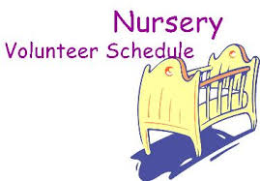

**Aug 2……………….Cissy Atwood**

**Aug 9……………..…Jana Moore**

**Aug 16…………..…Teresa Schane**

**Aug 23…….…..Ashley Smothermon**

**Aug 30….……..…..Paula Knobloch**

**Weekly Service & Activity Schedule:**

SUNDAY

Sunday School 9:45 a.m.

Morning Worship Services 11:00 a.m.

Evening Worship Services 6:00 p.m.

WEDNESDAY

Wednesday Bible Study. 7:00 p.m.

1662 CR 305

McDade, TX 78650

Phone: (512) 273-2743

Email: [KnobbsSpringsBaptist@gmail.com](mailto:KnobbsSpringsBaptist@gmail.com)



*KnobbsSpringsBC.com*

**David Atwood – Pastor**

**(512) 470-5098**

*Other Contacts*

*Cleyon Davis – Treasurer*

(512) 856-2524

*Patti Radford - Office Manager*

*KnobbsSpringsBaptist@gmail.com*

512-273-2743

**August Ushers**

Terry Robinson, Jimmy Miller

Joe Daniel, Wesley McManus

**August Hostesses**

Judie Coffey, Evelyn Robinson,

Sheila Waggoner

WHAT’S GOING ON?



Kids In Action will be temporarily cancelled.



Every 2nd and 4th Thursday of the month

**Birthday Party!!**

**Elgin Nursing Home @3:00**

People are needed to help serve. Contact Otisann McManus 512-273-2890







August

9..……………...…….…Business Meeting

13...................................Adult Fellowship

13...Birthday Party – Elgin Nursing Home

27………………………..Adult Fellowship

30…….……..Smothermon Baby Shower



September

10………………….……..Adult Fellowship

13……….…………..….Business Meeting

13-19..Week of Prayer – Mary Hill Davis

24……….………………Adult Fellowship

27……….Rachel Edwards Bridal Shower

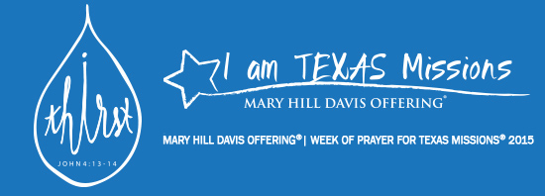

Please join us to honor Ashley Smothermon with a baby shower.

Sunday August 30 @ 12:00 pm

KSBC Fellowship Hall

**July 26 – July 30 Meal at 6:00 PM Worship Rally Kickoff at 6:30 PM Wrap up at 8:30 PM Ages Kindergarten – 6th Grade Hope to see you there as we study God’s word and have a great time!!**



As I write this, another Vacation Bible School is coming to a close. My heartfelt gratitude goes out to all who graciously gave their time, talents, and efforts to plant the seed of the love of Jesus Christ in the hearts and minds of these young children. Please continue to keep each and every one of these children in your prayers, that those seeds planted this week will grow, and these children will be constantly reminded that “This is the way; walk in it”. Pray those that haven’t already done so will place their faith and trust in Jesus as their Lord and Savior.

Also, pray that some of the parents of these children will see the difference in them, and that they themselves will also have a desire to learn more about the change they see in their children.

As we begin a new month, we draw closer to the end of summer and the beginning of a new school year. For those of you planning a last vacation trip, please be careful, have fun, and make sure to invite Jesus to be a part of your vacation time with your family.

God has graciously answered some of our prayers in the last few days, as we continue to look to Him for our daily needs. Please continue to remember all in our church family who need healing and encouragement.

I would also ask that we all take an active part in glorifying the Lord with our presence and the talents He has given each of us, through our church services and the other activities of the church.

“Let us not give up meeting together, as some are in the habit of doing, but let us encourage one another – and all the more as you see the Day approaching”. Hebrews 10:25

God bless you all,

David

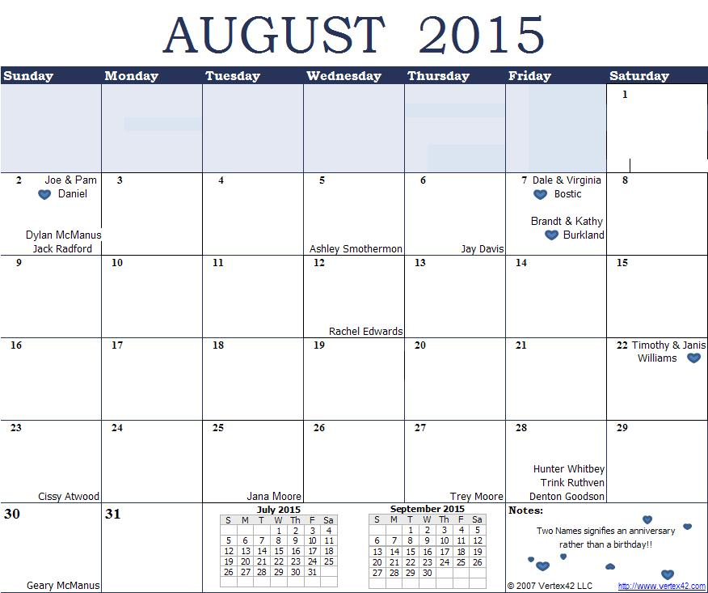

K s b c

**K**eeping His Word through **S**unday School, **B**ible Study and **C**hurch Attendance/Worship

Sunday School Bible Studies for August:

Aug 2nd Return to Prayer Nehemiah 1:3-10 Aug 9th Return to God’s Word Nehemiah 8:1-8 Aug 16th Return to Unity Acts 4:31-37 Aug 23rd Return to the Task Acts 13:1-3, 44-52 Aug 31st Hospitality: How Ordinary People Can Live on Mission Luke 14:12-24

**9:45 a.m. each Sunday – A place for everyone**

**WE’D LOVE FOR YOU TO JOIN US!**